Sri Lanka Institute of Information Technology



Lab Submission

Lab Sheet 08

**IT24102699  
Mummullage B.U.T**

**Probability and Statistics| IT2120**

B.Sc.(Hons) in Information Technology

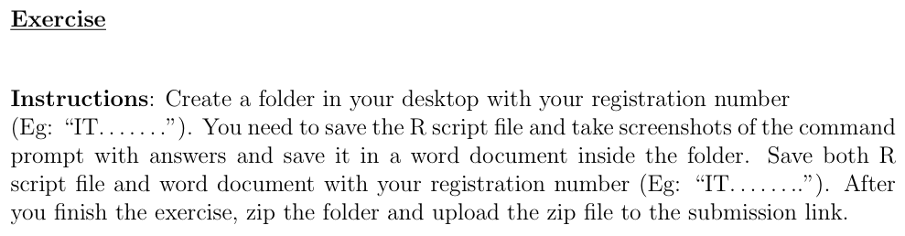



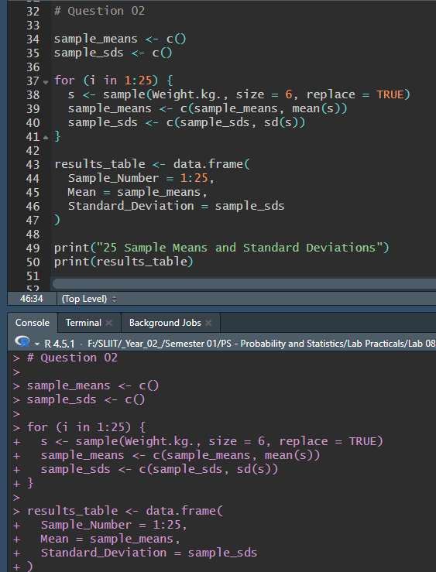

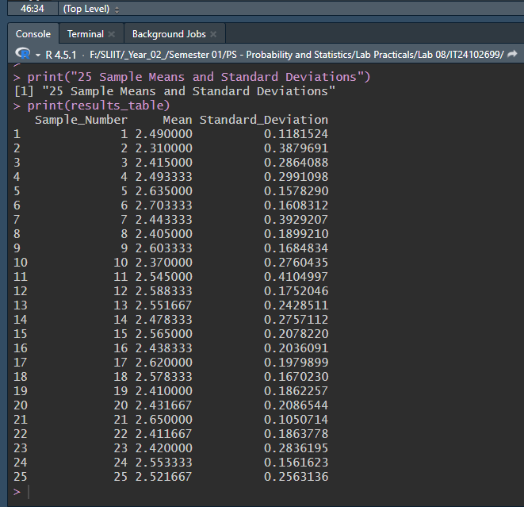



**Relationship:**

The mean of the sample means is approximately equal to the population mean.

**Relationship:**

The standard deviation of the sample means is approximately equal to the population standard deviation divided by the square root of the sample size.

**Self-Try Codes**

**Relationship:**

The mean of the sample means (samplemean) is approximately equal to the population mean (popmn). This demonstrates a key principle of the Central Limit Theorem.



**Relationship:**

The variance of the sample means (samplevars) is approximately equal to the population variance divided by the sample size, n (truevar). This shows that the distribution of sample means is less spread out than the population distribution.